CS-145
Programming Project 1
Classes and Methods

Objectives

- Be able to use objects made up of other objects
- Be able to write a class from scratch
- Be able to write methods

Introduction

For this project you will design a set of classes that work together to simulate a police officer issuing a parking ticket. The classes you should design are:
- The ParkedCar Class: This class should simulate a parked car. The class’s responsibilities are:
  - To know the car’s make, model, color, license number, and the number of minutes that the car has been parked.
- The ParkingMeter Class: This class should simulate a parking meter. The class’s only responsibility is:
  - To know the number of minutes of parking time that has been purchased.
- The ParkingTicket Class: This class should simulate a parking ticket. The class’s responsibilities are:
  - To report the make, model, color, and license number of the illegally parked car.
  - To report the amount of the fine, which is $25 for the first hour or part of an hour that the car is illegally parked, plus $10 for every additional hour or part of an hour that the car is illegally parked.
  - To report the name and badge number of the police officer issuing the ticket.
- The PoliceOfficer Class: This class should simulate a police officer inspecting parked cars. The class’s responsibilities are:
  - To know the police officer’s name and badge number
  - To examine a ParkedCar object and a ParkingMeter object, and determine whether the car’s time has expired
  - To issue a parting ticket (generate a ParkingTicket object) if the car’s time has expired.

These classes can be represented with the following UML diagrams:

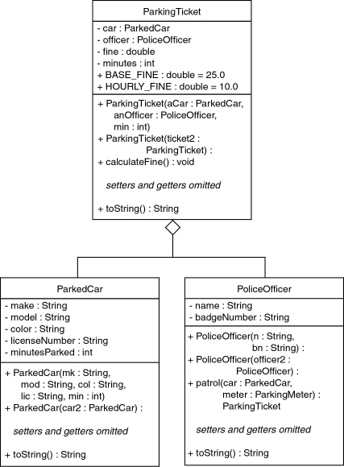

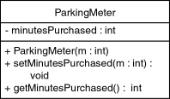

Task #1 Coding the UML Diagrams

Following the UML diagrams, create the classes as indicated. Compile and debug.

Task #2 Testing

Copy the files ParkingTicketSimulator.java and ParkingTicketSimulator2.java from Learn@UW-Stout. Compile and run ParkingTicketSimulator.java. The car in this program was parked for longer than the time purchased on the parking meter. You should get the following output:

Car Data:
Make: Volkswagen
Model: 1972
Color: Red
License Number: 147RHZM
Minutes Parked: 125
Officer Data:
Name: Joe Friday
BadgeNumber: 4788
Minutes Illegally Parked: 65
Fine: $35.00

Compile and run ParkingTicketSimulator2.java. The car in this program was legally parked. You should get the following output.

No crimes committed!

Code Listing ParkingTicketSimulator.java

/**
ParkingTicketSimulator program
Parking Ticket Simulator
*/

public class ParkingTicketSimulator
{
public static void main(String[] args)
{
// Create a ParkedCar object.
// The car was parked for 125 minutes.
ParkedCar car = new ParkedCar("Volkswagen", "1972", "Red",
"147RHZM", 125);

// Create a ParkingMeter object. 60 minutes were purchased.
ParkingMeter meter = new ParkingMeter(60);

// Create a PoliceOfficer object.
PoliceOfficer officer = new PoliceOfficer("Joe Friday",
"4788");

// Let the officer patrol.
ParkingTicket ticket = officer.patrol(car, meter);

// Did the officer issue a ticket?
if (ticket != null)
System.out.println(ticket);
else
System.out.println("No crimes committed!");
}
}

Code Listing ParkingTicketSimulator2.java

/**
ParkingTicketSimulator program
Parking Ticket Simulator
*/

public class ParkingTicketSimulator2
{
public static void main(String[] args)
{
// Create a ParkedCar object.
// The car was parked for 60 minutes.
ParkedCar car = new ParkedCar("Volkswagen", "1972", "Red",
"147RHZM", 60);

// Create a ParkingMeter object. 60 minutes were purchased.
ParkingMeter meter = new ParkingMeter(60);

// Create a PoliceOfficer object.
PoliceOfficer officer = new PoliceOfficer("Joe Friday",
"4788");

// Let the officer patrol.
ParkingTicket ticket = officer.patrol(car, meter);

// Did the officer issue a ticket?
if (ticket != null)
System.out.println(ticket);
else
System.out.println("No crimes committed!");
}
}

Submission Guidelines
Your submission into the Canvas should include all project source code, and sample output (test run). Each program should be properly formatted code with indenting, comments and well named variables.

Ethical Programming Guidelines
This is an individual assignment; the work you turn in must be yours and yours alone. Failure to follow these guidelines is punishable according to the syllabus:
- You are free to share conceptual ideas with fellow students (BUT NOT CODE).
- You are free to use any example code provided by the instructor.
- You may NOT share code with another student.
- You may NOT “team” code.
- You may NOT coach code another student or allow someone to coach you.
- You may NOT solicit answers from the Internet (crowd-source your project).

